**Example** 1. A program to reverse a string using bitwise operator

#include<stdio.h>

#include<string.h>

#include<conio.h>

char *reverse(char *ptr, int start, int end);

int main()

{

char string[20];

int iIndex=0, eIndex;

char reversed[20];

printf("Enter the string:\n");

gets(string);

eIndex = strlen(string)-1;

printf("The reversed string:\n");

printf("%s\n", reverse(string, iIndex, eIndex));

getch();

return 0;

}

// Function to reverse the string

char *reverse(char *ptr, int start, int end) {

while(start<end)

{

ptr[start] = ptr[start]^ptr[end];

ptr[end] = ptr[start]^ptr[end];

ptr[start] = ptr[start]^ptr[end];

++start;

--end;

}

return(ptr); }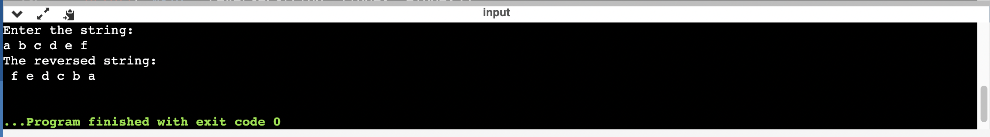

Example 2. A program to print the binary equivalent of an integer number using  bitwise operator.

#include<stdio.h>

int main()

{

int n,i,x;

printf(" Please, Enter a Number : ");

scanf("%d",&n);

printf("\n ");

for(i=7;i>=0;i--)

{

x=n&(1<<i);

if(x==0)

printf("0");

else

printf("1");

}

return 0;

}

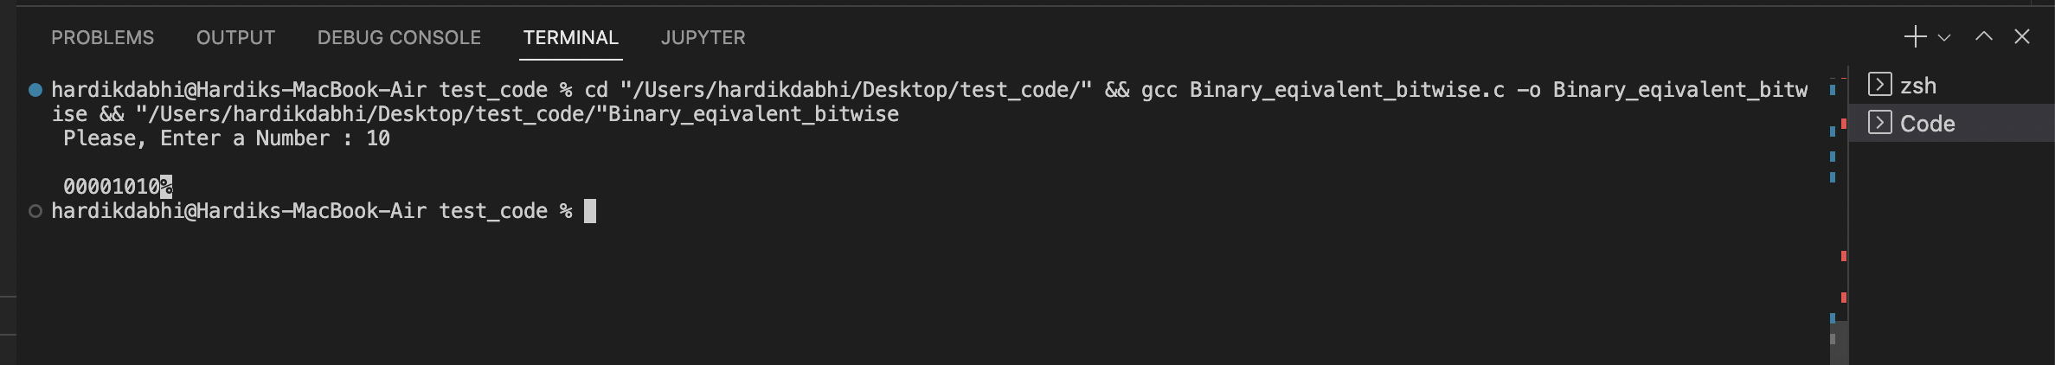

Example 3: A program to rotate a given number called value, n number of  times. If n is positive, rotate it left, otherwise right. It is to be noted that rotation  means shifting each bit by one place and recovering the lost bit. For example, in a  left shift, each bit is shifted one place to the left and the leftmost bit, which  comes out is returned to the rightmost place.

#include<stdio.h>

#define INT_BITS

int leftRotate(int number, unsigned int d);

int rightRotate(int number, unsigned int d);

void printbinary(int num);

int leftRotate(int number, unsigned int d) {

return ((number << d)|(number >> (INT_BITS - d))); }

int rightRotate(int number, unsigned int d) {

return (number >> d)|(number << (INT_BITS - d)); }

void printbinary(int num) {

for (int i=7; i>=0; i--) {

printf("%d",(num >> i) & 1); }

printf("\n"); }

int main() {

int n, value;

printf("Enter a number: ");

scanf("%d\n",&value);

printf("Enter the number of rotations: ");

scanf("%d\n",&n);

printbinary(value);

// If n is negative

if (n<0)

{

n = -(n);

value = rightRotate(value, n);

printf("After right shift, the value is %d \n",value);

printbinary(value); }

// If n is positive

else if (n>0)

{

value = leftRotate(value, n);

printf("After left shift, the value is %d \n",value);

printbinary(value); }

}

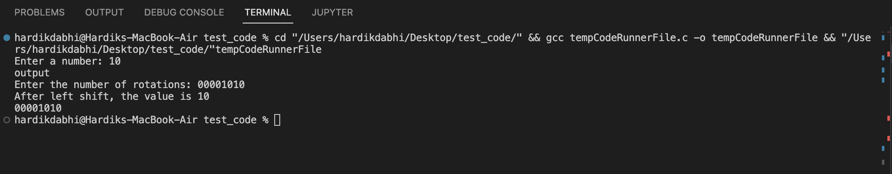

Example 5: Write a cpy command to operate like the UNIX cp or MSDOS COPY  command that takes its text fi les from the command line as follows.

#include<stdio.h>

int main(int argc,char*argv[]){

FILE *fp1,*fp2;

fp1=fopen(argv[1],'r');

fp2=fopen(argv[2],'w');

if (!fp1||!fp2||argc!=3){

printf("invalid parameter\n");

}

char c;

while((c=getc(fp1)!=EOF)){

fputc(c,fp2);

}

fclose(fp1);

fclose(fp2);

return 0;

}

Example 6: Write a program that prints the largest among three numbers.

// Write a program that prints the largest among three number

#include <stdio.h>

int main() {

float a,b,c;

printf("Enter the first value :");

scanf("%f",&a);

printf("Enter the second value :");

scanf("%f",&b);

printf("Enter the third value :");

scanf("%f",&c);

if (a>b && a>c)

printf("Largest number is :- %f",a);

else if (b>a && b>c)

printf("Largest number is :-%f",b);

else

printf("Largest number is :-%f",c);

return 0;

}

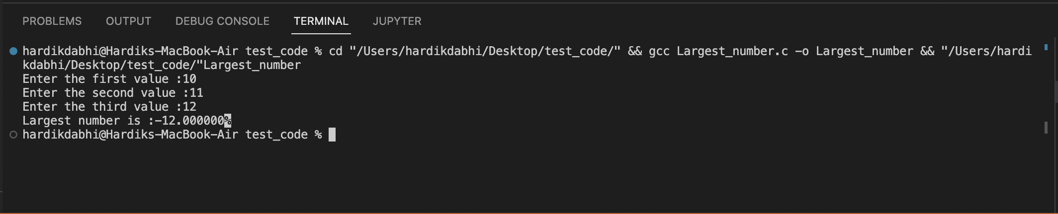

Example 7: Write a program in C to check whether a number given by the user is  odd or even.

#include<stdio.h>

int main(){

int a;

printf("Enter the value : ");

scanf("%d",&a);

if (a%2==0)

printf("NUmber is Even = %d",a);

else

printf("Number is odd = %d",a);

return(0);

}

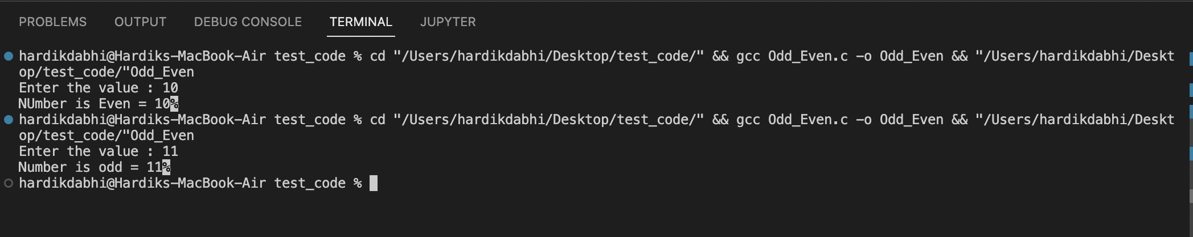

Example 8: Write a program in C to check whether a number given by the user is  zero, positive, or negative

#include<stdio.h>

int main(){

int a;

printf("Enter the value :");

scanf("%d",&a);

if (a==0)

printf("Number is Zero = %d",a);

else if (a<0)

printf("Number is Negative = %d",a);

else

printf("Number is Positive = %d",a);

}

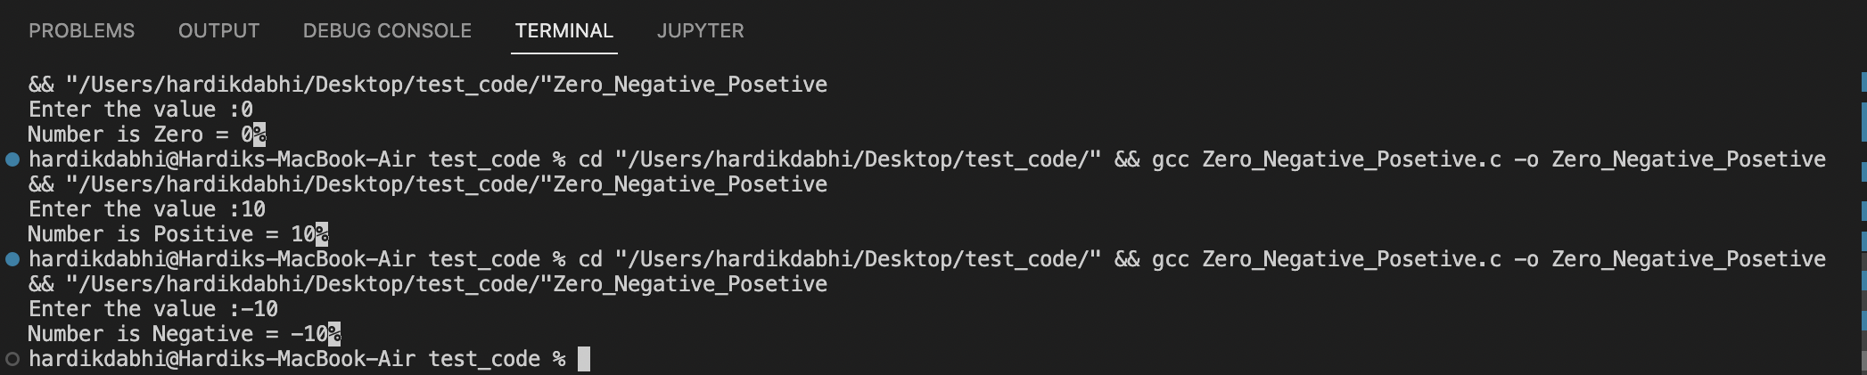

Example 9: Write a program in C that prints the grade according to the score  secured by a student.

#include<stdio.h>

int main(){

int a;

printf("Enter your Mark :");

scanf("%d",&a);

if (a>=90)printf("Your grade is = A+");

else if (a>=80)printf("Your grade is = A");

else if (a>=70)printf("Your grade is = B+");

else if (a>=60)printf("Your grade is = B");

else if (a>=50)printf("Your grade is = C+");

else if (a>=40)printf("Your grade is = C");

else printf(" FAIL ");

return(0);

}

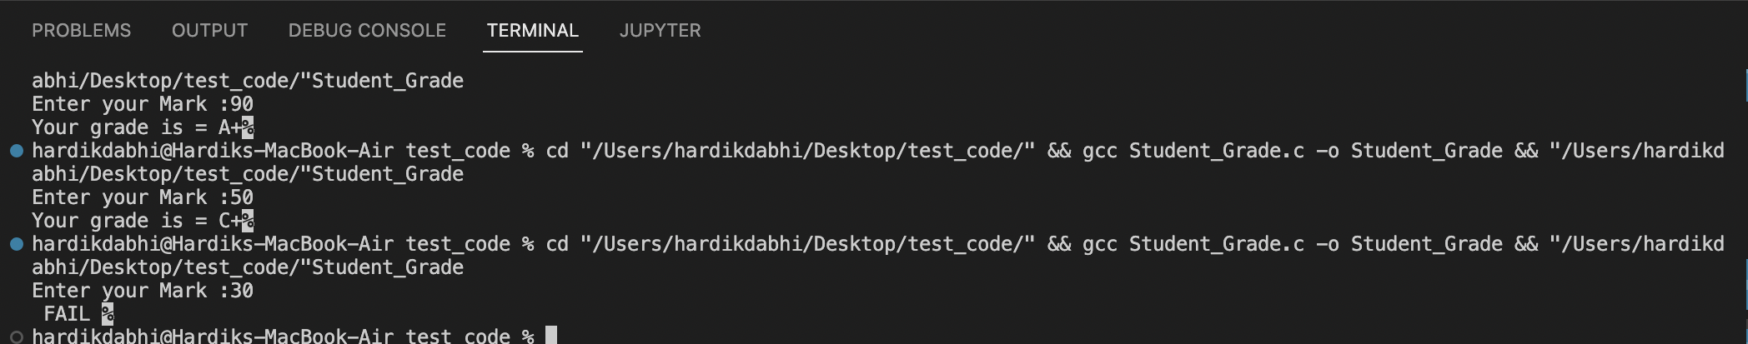

Example 10: Write a program using a switch statement to check whether a  number given by the user is odd or even.

#include<stdio.h>

int main(){

int a;

printf("Enter the value : ");

scanf("%d",&a);

switch(a%2)

{

case 0:printf("Number is Even = %d",a);

break;

case 1:printf("Number is Odd = %d",a);

break;

default:printf("Number is Odd = %d",a);

break;

}

}

